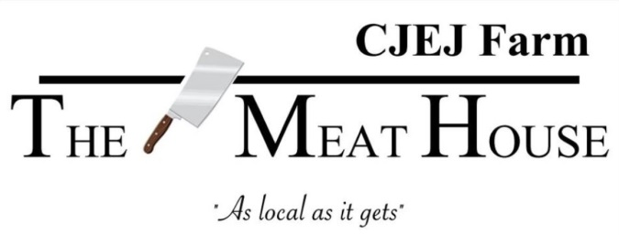
Sheep/Goat Cutting Instructions

Organ meat - Heart, Liver, Tongue, None

Leg - Roast whole with bone-in or boned and rolled ($5)
cut in half with bone-in
- Leg steaks ______ in.

Loin - Roast_____ lbs. Chops _____ in. _____/ pkg.

Ribs - Rack or Sliced

Shoulder - Roast whole or boned and rolled ($5)
- Steaks ______ in.
- Stew meat and/or Ground

Neck - Roast or Ground

Shank - Whole or Ground

Trimmings – Stew meat and/or Ground

Name : ___________________________

Address: ___________________________________________

Phone: ___________________________

Hanging Weight ______________

Organ Meat Weight ___________

